LAB 5

1.

TeeShirt.java

package mypack;  
  
public class TeeShirt {  
  
// Declaring instance variables  
  
 private int orderNum;  
  
 private String size;  
  
 private String color;  
  
 private double price;  
  
  
  
// getters and setters  
  
 public int getOrderNum() {  
  
 return orderNum;  
  
 }  
  
  
  
 public void setOrderNum(int orderNum) {  
  
 this.orderNum = orderNum;  
  
 }  
  
  
  
 public String getSize() {  
  
 return size;  
  
 }  
  
  
  
 public void setSize(String size) {  
  
 this.size = size;  
  
 }  
  
  
  
 public String getColor() {  
  
 return color;  
  
 }  
  
  
  
 public void setColor(String color) {  
  
 this.color = color;  
  
 }  
  
  
  
 public double getPrice() {  
  
 if (size.endsWith("XXL") || size.equalsIgnoreCase("XXXL"))  
  
 price = 22.99;  
  
 else  
  
 price = 19.99;  
  
  
  
 return price;  
  
 }  
  
  
  
}

CustomTees.java

package mypack;  
  
public class CustomTee extends TeeShirt {  
 // Declaring instance variables  
 private String slogan;  
  
 // getters and setters  
 public String getSlogan() {  
 return slogan;  
 }  
  
 public void setSlogan(String slogan) {  
 this.slogan = slogan;  
 }  
}

DemoTees.java

package mypack;  
  
  
public class DemoTees {  
  
  
  
 public static void main(String[] args) {  
  
 //Creatinga an Instance of TeeShirt Class  
  
 TeeShirt ts=new TeeShirt();  
  
 ts.setSize("XXXL");  
  
 ts.setOrderNum(1111);  
  
 ts.setColor("Red");  
  
 CustomTee cs=new CustomTee();  
  
 cs.setSlogan("Save Animals");  
  
//Displaying the output  
  
 System.*out*.println("Custom TeeShirt:\nOrder No :"+ts.getOrderNum()+"\nSize ="+ts.getSize()+"\nColor = "+ts.getColor());  
  
 System.*out*.println("Slogan = "+cs.getSlogan());  
  
 System.*out*.println("Price = $"+ts.getPrice());  
  
  
  
 }  
  
  
  
}

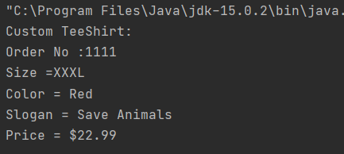

2.

SugarSmashPlayer.java

package javalab;  
public class SugarSmashPlayer{  
 int pid, count = 0, c = 0, temp = 0;  
 String sname;  
 int[] scores = new int[10];  
 int test = 100;  
 //scores[0] = 100;  
 public void setScores(int score, int level){  
 if(level >= 10)System.*out*.println("Please enter the level in range ");  
 else if(level - count > 1)System.*out*.println("at the wrong level O_O");  
 else if(temp == -1){  
 System.*out*.println("Can't assign score to the level ");  
 c = -1;  
 }  
 else scores[level] = score;  
 if(score < 100){  
 temp = -1;  
 }  
 else temp = 0;  
 this.count = level;  
 }  
 public boolean checkScore(){  
 if(temp == -1)return true;  
 return false;  
 }  
 public void setPid(int pid){  
 this.pid = pid;  
 }  
 public void setSname(String sname){  
 this.sname = sname;  
 }  
 public int getPid(){  
 return pid;  
 }  
 public String getSname(){  
 return sname;  
 }  
 public void getScores(int n){  
 for(int i = 0;i<n;++i)System.*out*.println(scores[i] + " ");  
 }  
}

PremiumSugarSmash.java

package javalab;  
public class PremiumSugarSmash extends SugarSmashPlayer{  
 int count = 0, temp;  
 double p = 2.99;  
 PremiumSugarSmash(double pay){  
 if(Double.*compare*(pay,p) == 0)System.*out*.println("Premium Version Is Unlocked ^_^");  
 else System.*out*.println("Incomplete payment : " + (2.99 - pay) + "need to be paid");  
 }

DemoSugarSmash.java

package javalab;  
import java.util.*;  
  
public class DemoSugarSmash{  
 public static void main(String[] args){  
 Scanner in = new Scanner(System.*in*);  
 int val, level, choice, r = 0;  
 double pay;  
 String name;  
 System.*out*.println("choose 1 for Premium version and 2 for demo version ");  
 choice = in.nextInt();  
 if(choice == 1){  
 System.*out*.println("enter the amount: ");  
 pay = in.nextDouble();  
 PremiumSugarSmash obj = new PremiumSugarSmash(pay);  
 System.*out*.println("enter the player id : " );  
 int pid = in.nextInt();  
 in.nextLine();  
 obj.setPid(pid);  
 System.*out*.println("enter the player name: ");  
 name = in.nextLine();  
 obj.setSname(name);  
 System.*out*.println("enter the Scores for each level ");  
 for(int i = 0;i<40;i++){  
 val = in.nextInt();  
 level = in.nextInt();  
 obj.setScores(val,level);  
 if(obj.checkScore() == true){  
 r = i;  
 break;  
 }  
 }  
 System.*out*.println("Player id: ");  
 System.*out*.println(obj.getPid());  
 System.*out*.println("Player name: ");  
 System.*out*.println(obj.getSname());  
 System.*out*.println("the scores are ");  
 obj.getScores(r);  
 }  
 else {  
 SugarSmashPlayer obj = new SugarSmashPlayer();  
 System.*out*.println("enter the player id : " );  
 int pid = in.nextInt();  
 obj.setPid(pid);  
 System.*out*.println("enter the player name: ");  
 String sname = in.nextLine();  
 obj.setSname(sname);  
 System.*out*.println("enter the Scores for each level ");  
 for(int i = 0;i<10;i++){  
 val = in.nextInt();  
 level = in.nextInt();  
 obj.setScores(val,level);  
 if(obj.checkScore() == true){  
 r = i;  
 break;  
 }  
 }  
 int id = obj.getPid();  
 System.*out*.println("Player id: ");  
 System.*out*.println(id);  
 System.*out*.println("Player name: ");  
 System.*out*.println(obj.getSname());  
 System.*out*.println("the scores are ");  
 obj.getScores(r);  
 }  
 }  
}

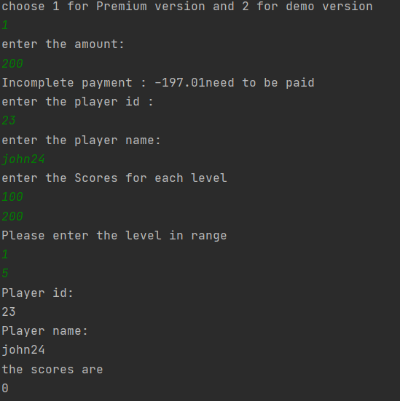

3.

CollegeCourse.java

package javalab;  
class CollegeCourse  
{  
 protected String department;  
 protected int course_number;  
 protected int credits;  
 protected double fee;  
  
 public CollegeCourse(String d, int c, int cr)  
 {  
 department = d;  
 course_number = c;  
 credits = cr;  
 fee = credits*120;  
 }  
 public void display()  
 {  
 System.*out*.println("Department is " + department);  
 System.*out*.println("Course number is " + course_number);  
 System.*out*.println("credits are " + credits);  
 System.*out*.println("Fee is " + fee);  
 }  
}

LabCourse.java

package javalab;  
class LabCourse extends CollegeCourse  
{  
 public LabCourse(String d, int c, int cr)  
 {  
 super(d,c,cr);  
 fee = fee + 50;  
 }  
  
 public void display()  
 {  
 System.*out*.println("Course is a lab course");  
 System.*out*.println("Department is " + department);  
 System.*out*.println("Course number is " + course_number);  
 System.*out*.println("credits are " + credits);  
 System.*out*.println("Fee is " + fee);  
 }  
}

UseCourse.java

package javalab;  
import java.util.Scanner;  
public class UseCourse{  
 public static void main(String[] args)  
 {  
 Scanner in = new Scanner(System.*in*);  
 System.*out*.println("Enter course Department :");  
 String d = in.next();  
 System.*out*.println("Enter course Number :");  
 int c = in.nextInt();  
 System.*out*.println("Enter course Credits :");  
 int cr = in.nextInt();  
  
 if(d.equals("BIO") || d.equals("CHM") || d.equals("CIS") || d.equals("PHY"))  
 {  
 LabCourse LC = new LabCourse(d, c, cr);  
 LC.display();  
 }  
  
 else  
 {  
 CollegeCourse CC = new CollegeCourse(d, c, cr);  
 CC.display();  
 }  
  
 }  
}

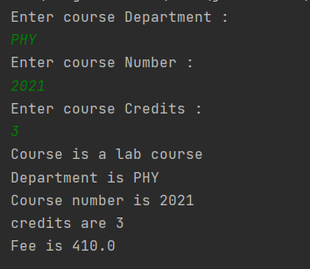

4.

NewspaperSubscription.java

abstract class NewspaperSubscription {  
 String name;  
 String address;  
 int rate;  
  
 void getdetails() {  
 Scanner sc= new Scanner(System.*in*);  
 System.*out*.print("Enter name: ");  
 name = sc.nextLine();  
 System.*out*.print("Enter address: ");  
 address = sc.nextLine();  
 System.*out*.print("Enter rate: ");  
 rate = sc.nextInt();  
  
 setAddress(address);  
 }  
 void displaydetails() {  
 System.*out*.printf("%nName: %s%nAddress: %s%nRate: %d%n", name, address, rate);  
 }  
  
 abstract void setAddress(String a);  
}

PhysicalNewspaperSubscription.java

class PhysicalNewspaperSubscription extends NewspaperSubscription {  
 void setAddress(String a) {  
 if (!a.matches(".[0**-**9].")) {  
 rate = 0;  
 System.*out*.print("Incorrect address");  
 } else {  
 rate = 15;  
 }  
 }  
}

OnlineNewspaperSubscription.java

class onlineNewspaperSubscription extends NewspaperSubscription {  
 void setAddress(String a) {  
 if (!a.contains("@")) {  
 rate = 0;  
 System.*out*.print("Incorrect address");  
 } else {  
 rate = 9;  
 }  
 }  
}

Driver.java

class Driver {  
 public static void main(String[] args) {  
 PhysicalNewspaperSubscription p = new PhysicalNewspaperSubscription();  
 onlineNewspaperSubscription o = new onlineNewspaperSubscription();  
  
 p.getdetails();  
 o.getdetails();  
  
 p.displaydetails();  
 o.displaydetails();  
 }  
}

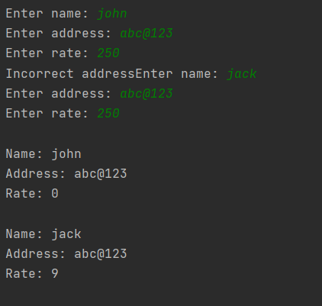

5.

ElectricBlanket.java

package javalab;  
import java.util.Scanner;  
class ElectricBlanket extends Blanket  
{  
 private int heatNum;  
 private boolean isAuto;  
 public ElectricBlanket()  
 {  
 super();  
 heatNum= -1;  
 isAuto=false;  
 }  
  
 public void setHeatNum(int num)  
 {  
 if(num>=1 && num<=5)  
 {  
 heatNum=num;  
 }  
 else  
 {  
 heatNum=1;  
 }  
  
 }  
  
 public void setAuto(boolean auto)  
 {  
 if(isAuto && !auto)  
 {  
 price -=5.75;  
 }  
 else if(!isAuto && auto)  
 {  
 price+=5.75;  
 }  
 isAuto=auto;  
 }  
  
 public int getHeatNum()  
 {  
 return heatNum;  
 }  
 public boolean getAuto()  
 {  
 return isAuto;  
 }  
 public String toString()  
 {  
 String info ="No.of Heat settings="+heatNum+"\n"+"Has Auto shutoff feature"+isAuto+"\n";  
 info +=super.toString();  
 return info;  
 }  
}

Blanket.java

package javalab;  
import java.util.Scanner;  
class Blanket  
{  
 protected String size;  
 protected String color;  
 protected String material;  
 protected double price;  
  
 public Blanket()  
 {  
 size="Twin";  
 color="white";  
 material="cotton";  
 price=30;  
 }  
  
 public void setSize(String newSize)  
 {  
  
 price=30;  
  
 if(newSize.compareToIgnoreCase("double")==0)  
 {  
 size = newSize;  
 price+=10;  
 if(material.compareToIgnoreCase("wool")==0)  
 {  
 price +=20;  
 }  
 else if(material.compareToIgnoreCase("cashmere")==0)  
 {  
 price+=45;  
 }  
 }  
 else if(newSize.compareToIgnoreCase("queen")==0)  
 {  
 size= newSize;  
 price+=25;  
 if(material.compareToIgnoreCase("wool")==0)  
 {  
 price+=20;  
 }  
 else if(material.compareToIgnoreCase("cashmere")==0)  
 {  
 price+=45;  
 }  
 }  
 else if(newSize.compareToIgnoreCase("king")==0)  
 {  
 size=newSize;  
 price+=40;  
 if(material.compareToIgnoreCase("wool")==0)  
 {  
 price+=20;  
 }  
 else if(material.compareToIgnoreCase("cashmere")==0)  
 {  
 price+=45;  
 }  
 }  
 else if(newSize.compareToIgnoreCase("twin")==0)  
 {  
 size =newSize;  
 price=30;  
  
 if(material.compareToIgnoreCase("wool")==0)  
 {  
 price+=20;  
 }  
 else if(material.compareToIgnoreCase("cashmere")==0)  
 {  
 price+=45;  
 }  
 }  
 else  
 {  
 size="Twin";  
 price=30;  
 material="cotton";  
 }  
 }  
  
 public void setMaterial(String newMat)  
 {  
 if(newMat.compareToIgnoreCase("wool")==0)  
 {  
 material=newMat;  
 setSize(size);  
 }  
 else if(newMat.compareToIgnoreCase("cashmere")==0)  
 {  
 material=newMat;  
 setSize(size);  
 }  
 else if(newMat.compareToIgnoreCase("cotton")==0)  
 {  
 material=newMat;  
 setSize(size);  
 }  
 else  
 {  
 size="Twin";  
 price=30;  
 material="cotton";  
 }  
 }  
 public void setColor(String newCol)  
 {  
 color=newCol;  
 }  
  
 public String toString()  
 {  
 return "Size:" +size+ "\n"+  
 "Color:" +color+ "\n"+  
 "Material:" +material+ "\n"+  
 "Price: $" +price+ "\n";  
 }  
}

DemoBlankets.java

package javalab;  
  
import java.util.Scanner;  
class DemoBlankets  
{  
 public static void main(String[] args)  
 {  
 System.*out*.println("checking the working"+"of class Blanket");  
 System.*out*.println("creating an object...\n");  
  
 Blanket newBlanket= new Blanket();  
 System.*out*.println("calling the toString() method...\n");  
 System.*out*.println(newBlanket.toString());  
 System.*out*.println("Changing the blanket"+"size from twin size to king size...\n");  
  
 newBlanket.setSize("king");  
 System.*out*.println(newBlanket.toString());  
 System.*out*.println("Changing the material"+"from cotton to cashmere...\n");  
  
 newBlanket.setMaterial("cashmere");  
 System.*out*.println("Calling the toString() method...\n");  
 System.*out*.println(newBlanket.toString());  
  
 System.*out*.println("Changing the color"+"of the blanket to Blue...\n");  
 newBlanket.setColor("blue");  
 System.*out*.println(newBlanket.toString());  
 System.*out*.println("\nChecking the working of the class ElectricBlanket");  
 System.*out*.println("Creating an object...\n");  
  
 ElectricBlanket newElecBlanket= new ElectricBlanket();  
 System.*out*.println("Calling the toString() method...\n");  
  
 System.*out*.println(newElecBlanket.toString());  
  
 System.*out*.println("Including an automatic"+"shutoff feature in the blanket...\n");  
  
 newElecBlanket.setAuto(true);  
  
 System.*out*.println("Changing the number"+"of heat settings to 3...\n");  
  
 newElecBlanket.setHeatNum(3);  
  
 System.*out*.println("calling the toString() method...\n");  
  
 System.*out*.println(newElecBlanket.toString());  
 }  
}

